**week 4 - (02-12-2024) Azure pipelines**

**Toipic:**

1. Create **job** in Hexa2 workspace
2. Creating **tasks** inside a job
3. Creating **Data Storage account** (blob service) – it is mainly used only for storage of data.
4. Create **container**(folder) inside blob data storage
5. Creating **Data Lake storage** – we can integrate and it have analytical uses. – hierarchical namespace is enabled
6. Create container(folder) inside data lake storage

Reference:

<https://drive.google.com/file/d/1XgJVHuicDlP-AnefQmaJybqf3RGHNTbn/view?usp=drive_link>

<https://drive.google.com/file/d/1_WGRhWnXXpw_UwnkfN4XnX-ihBZmUUOS/view?usp=drive_link>

**Create jobs**

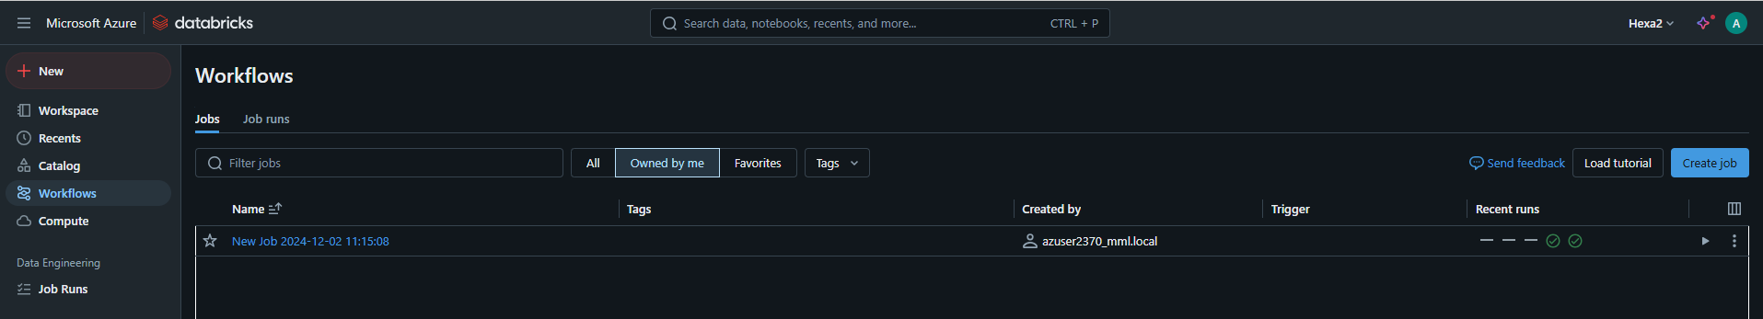

**Creating tasks inside a job**

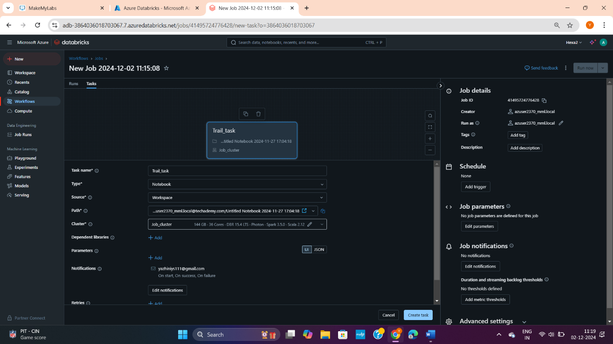

**Adding notifications and path** (the notebook that have to run while we run this particular task). Note if I click run job it will run all the tasks inside it where each task will have 1 notebook path.

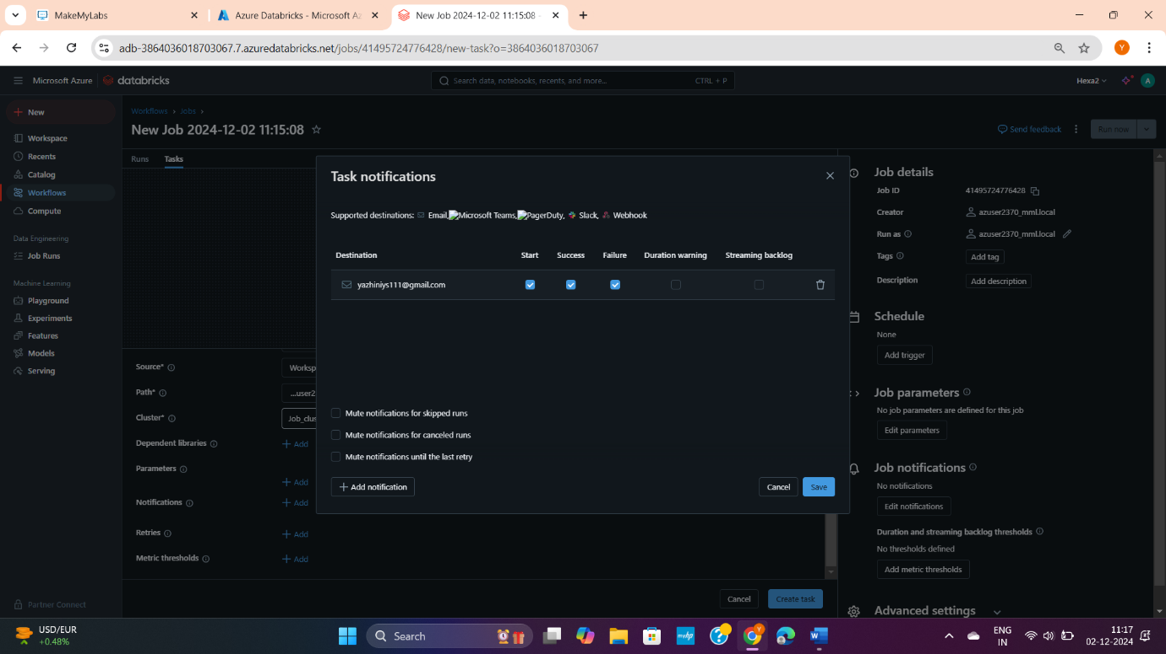

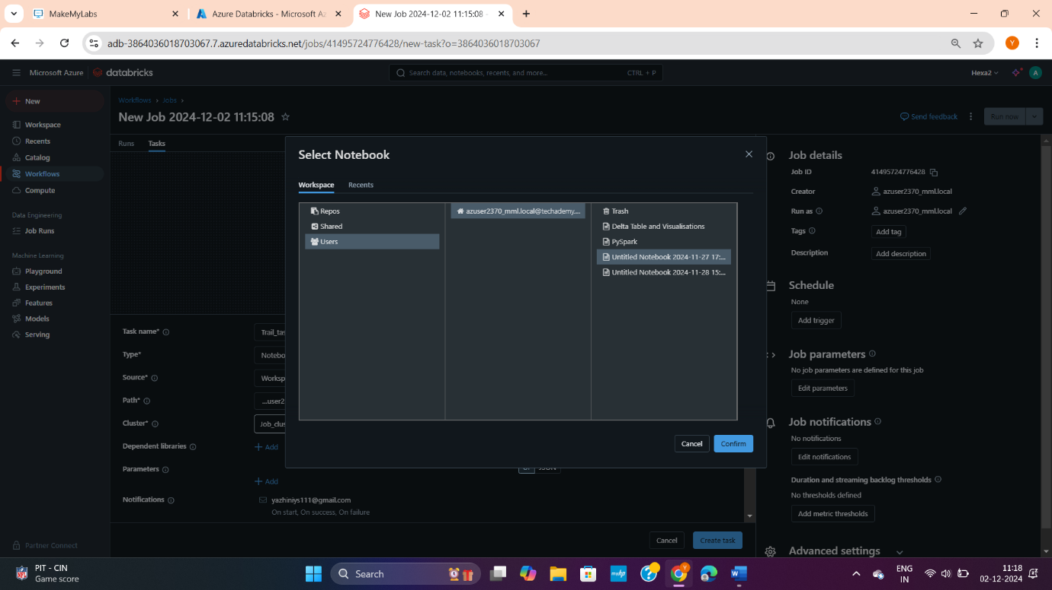

After creating a task. **Click run now**. (Here I gave run 2 times. Similarly, all the run history is here)

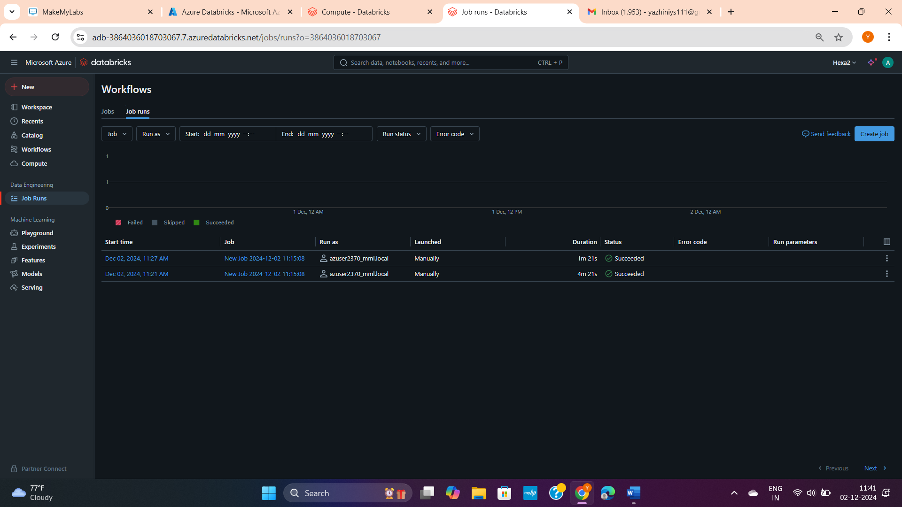

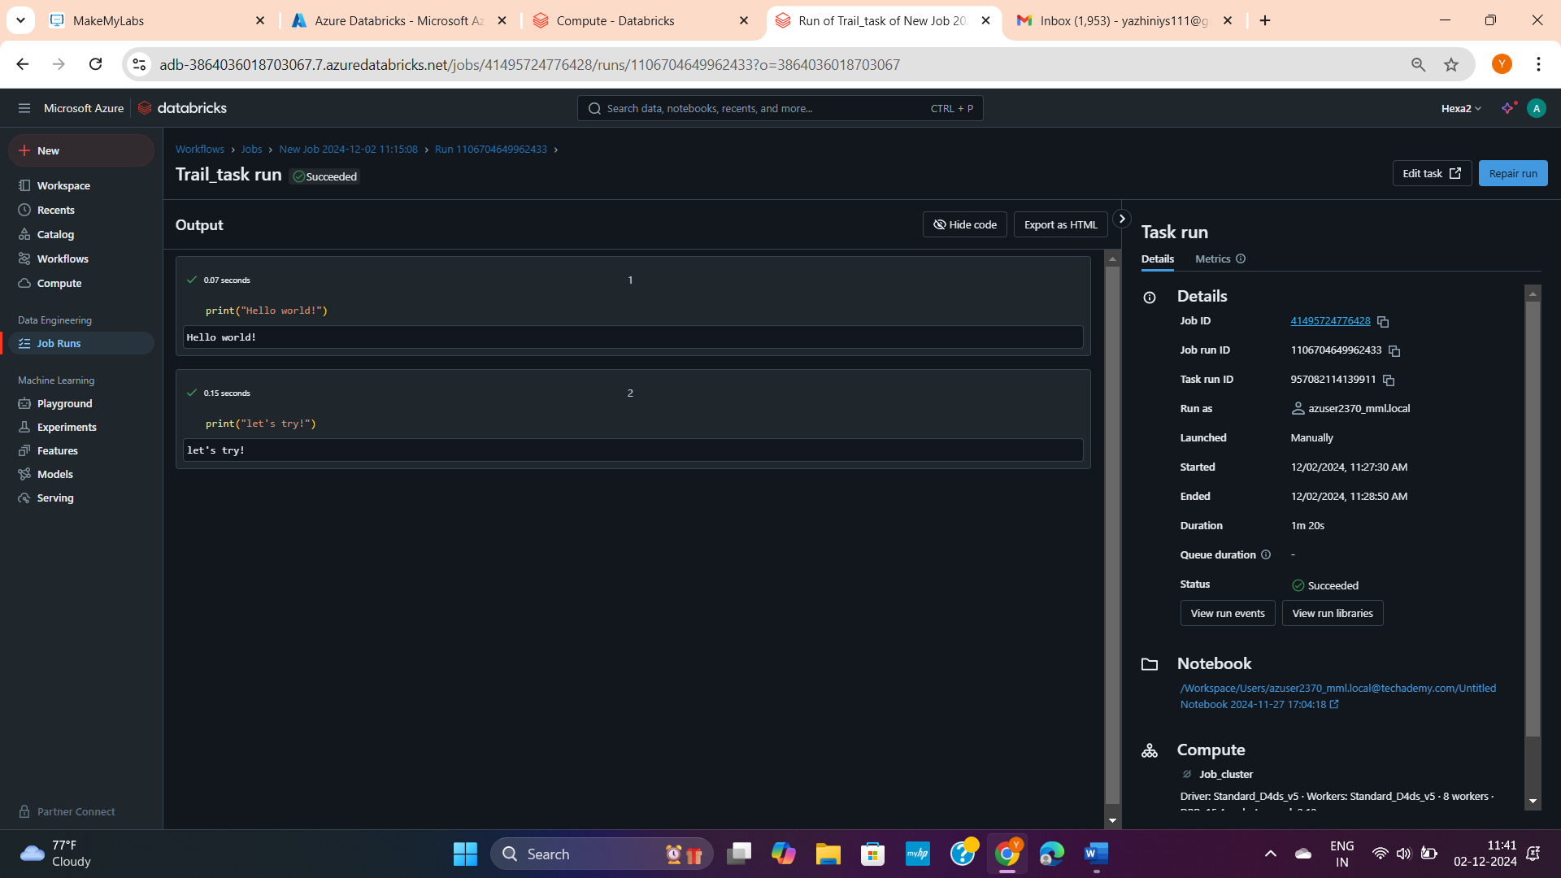

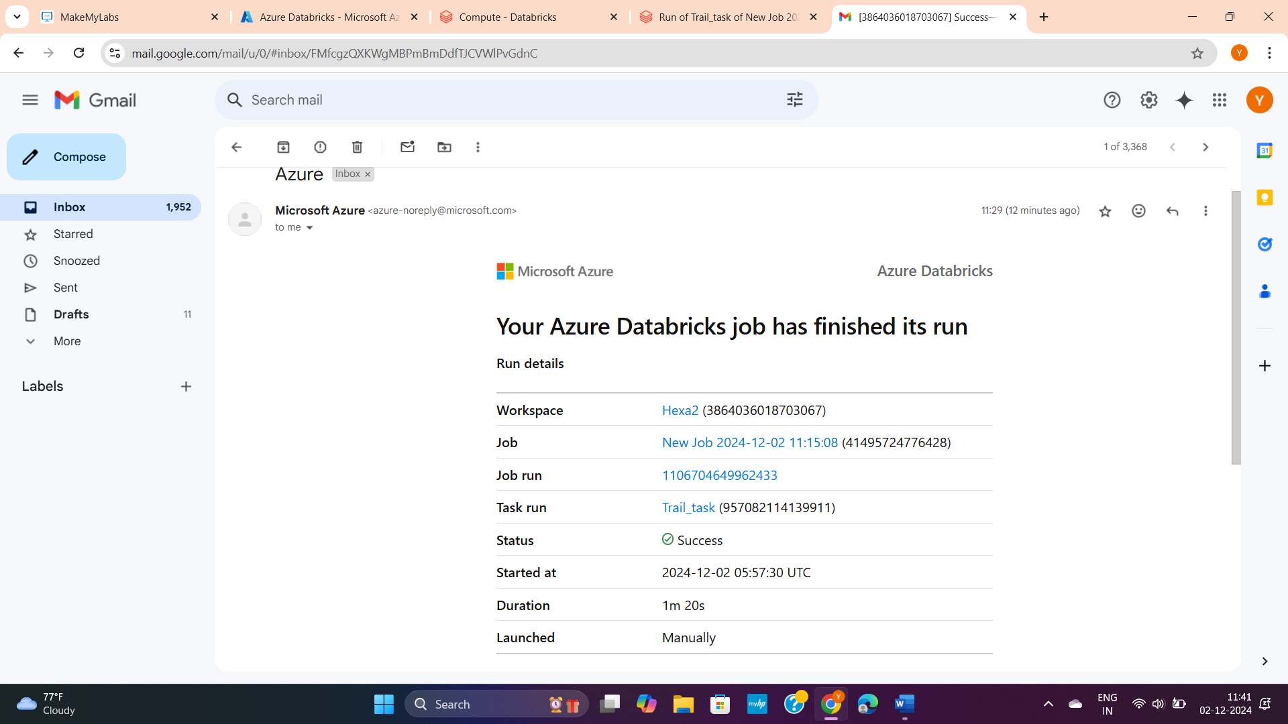

**Creating Data Storage account (blob service)**



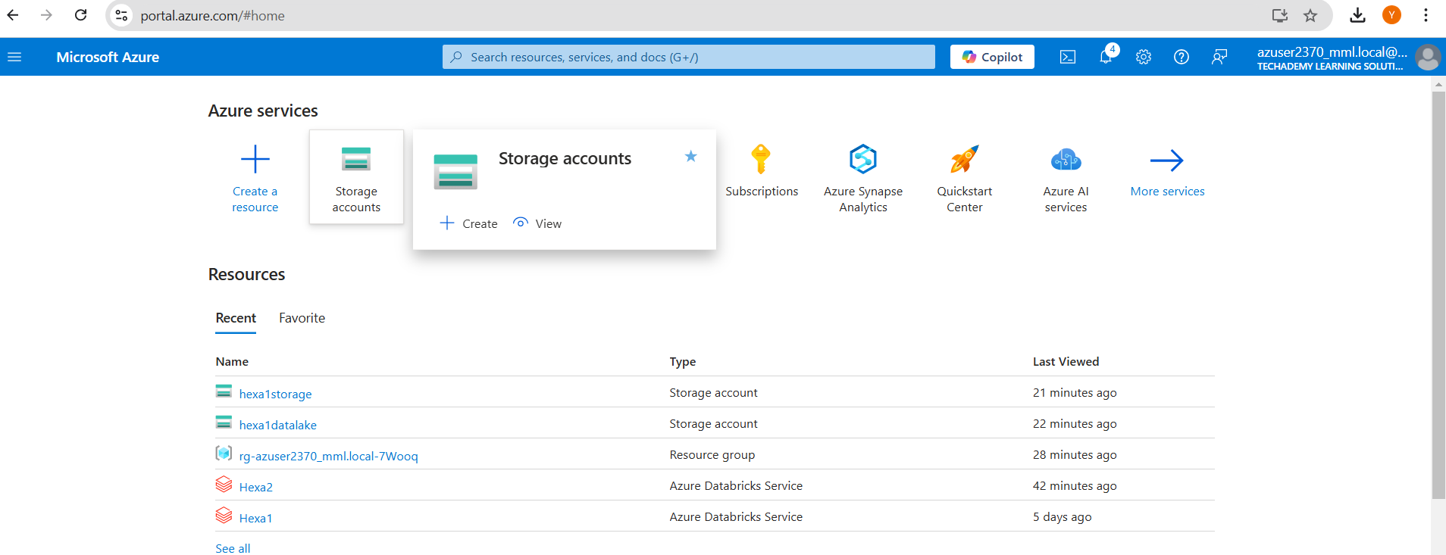

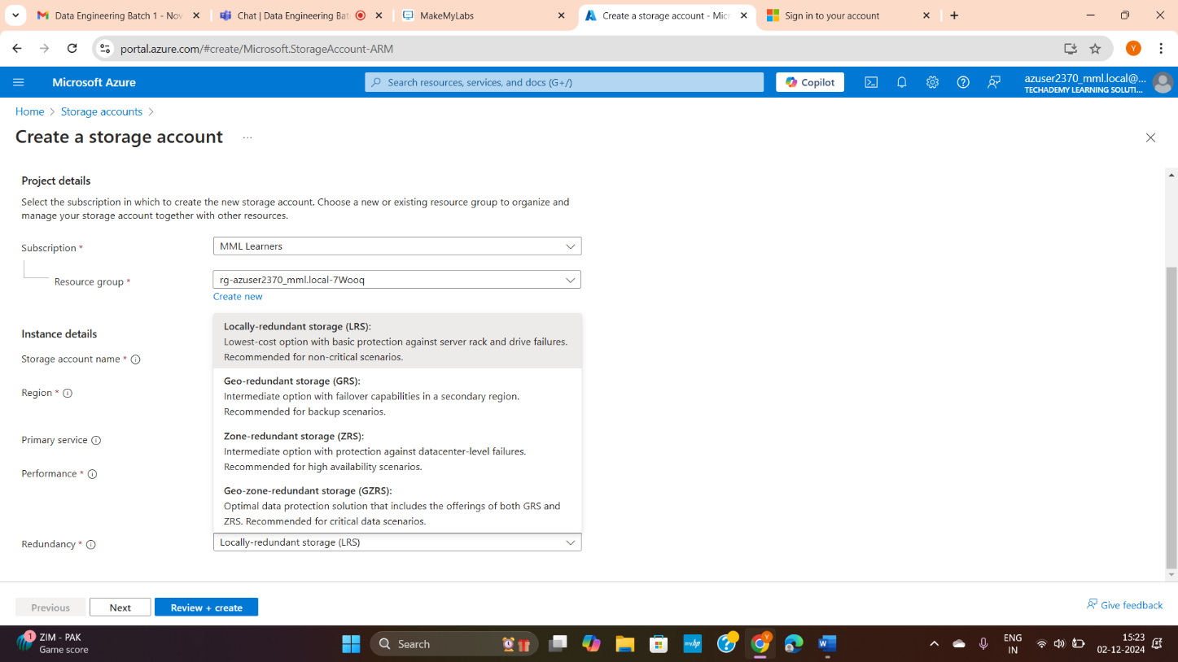

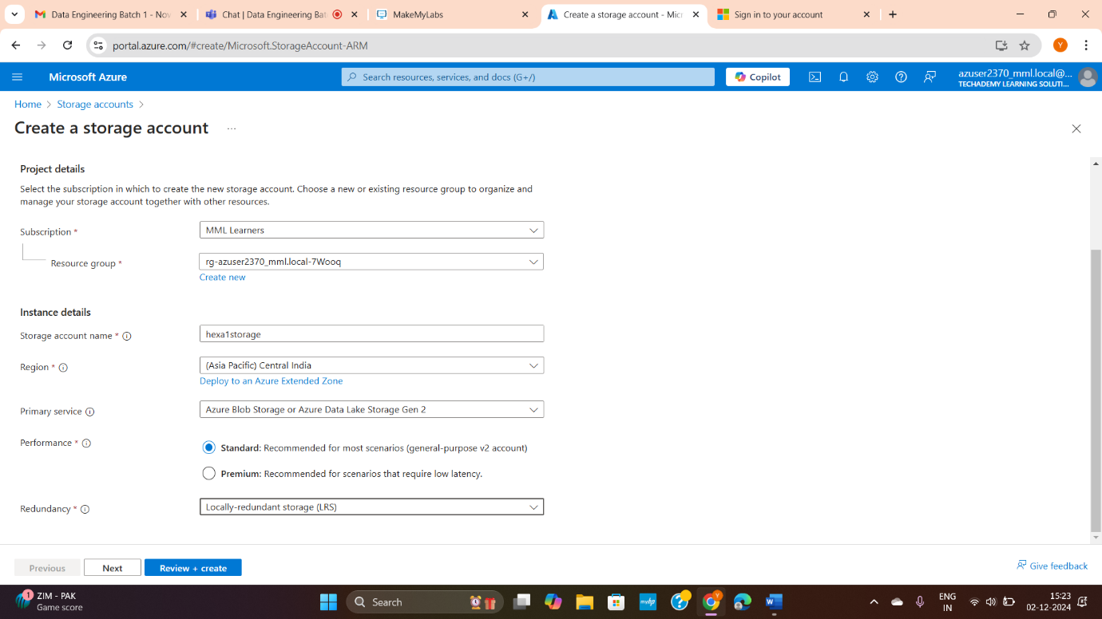

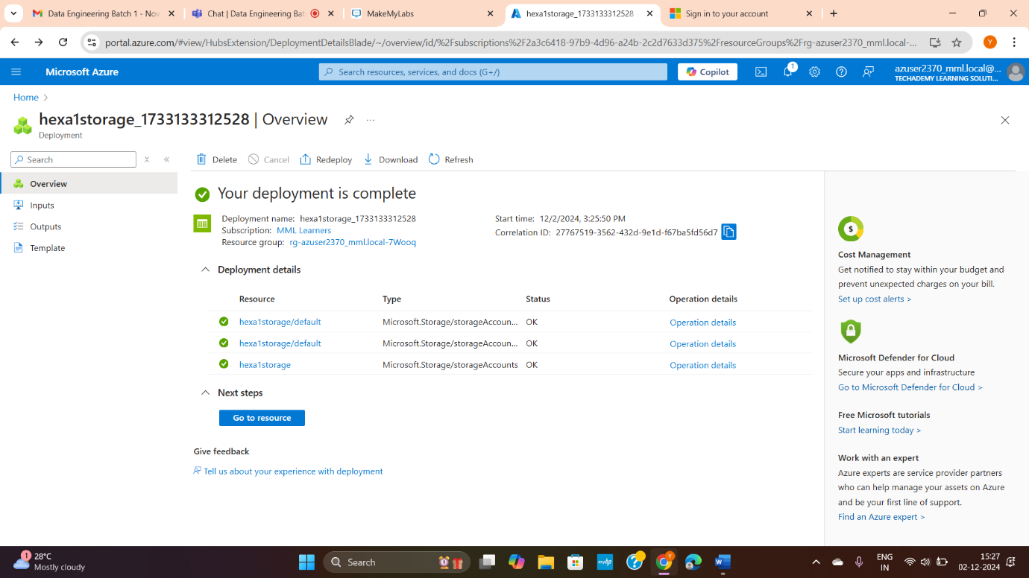

Go to resources or click the data storage name:

Note inside property: it is mentioned as Blob service + hierarchical namespace is disabled.

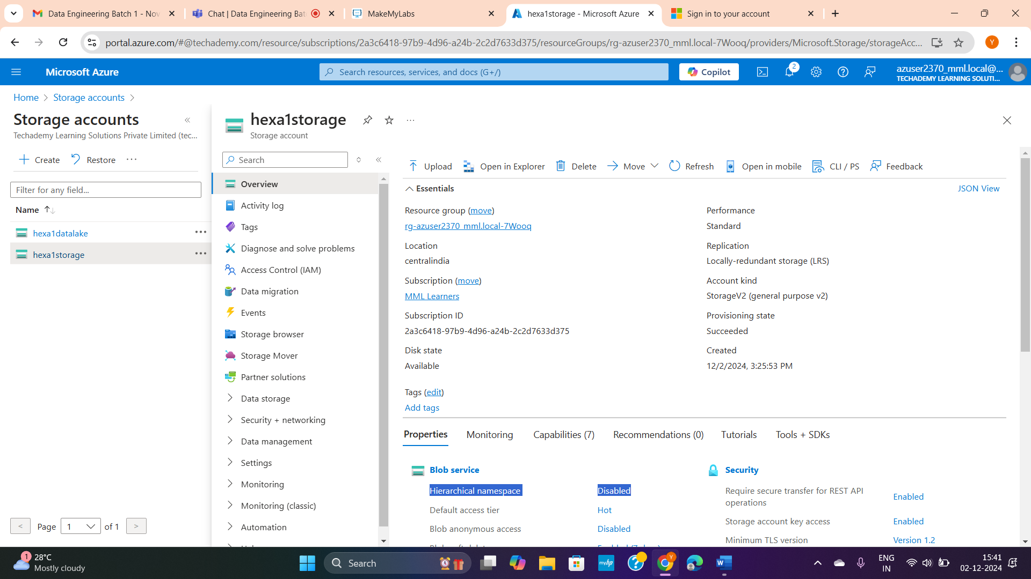

**Creating Data Lake storage**

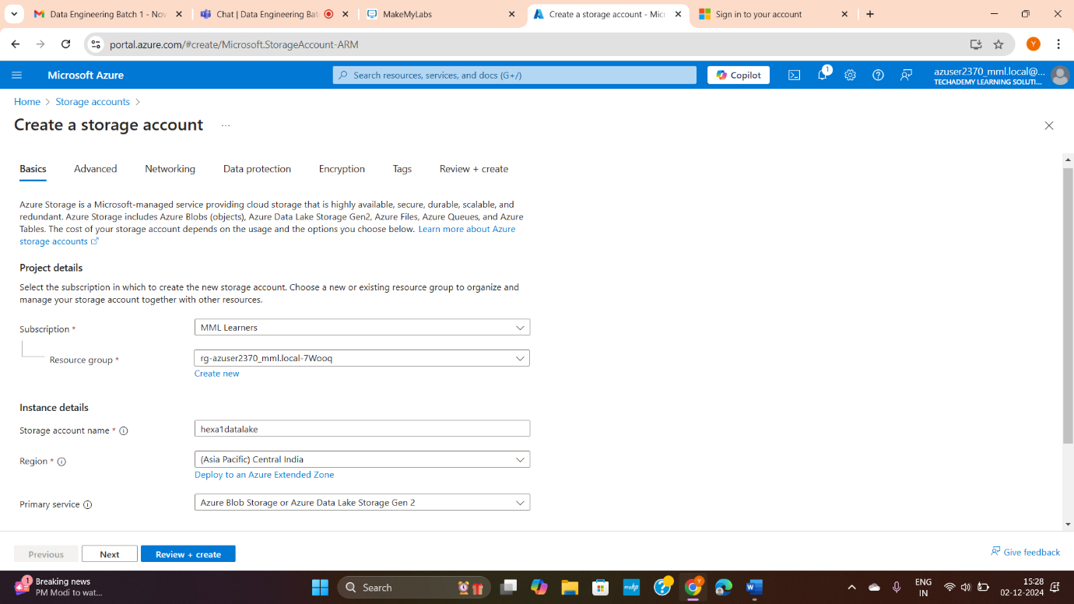

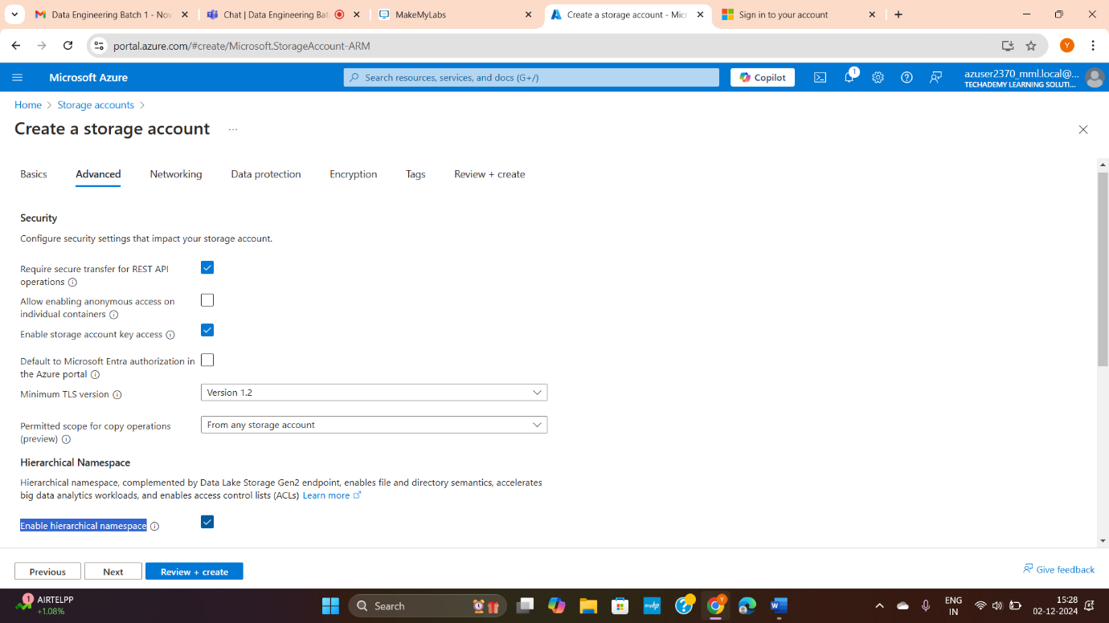

Go to resources or click the data storage name:

Note inside property: it is mentioned as Data Lake Storage + **hierarchical namespace is enabled.**

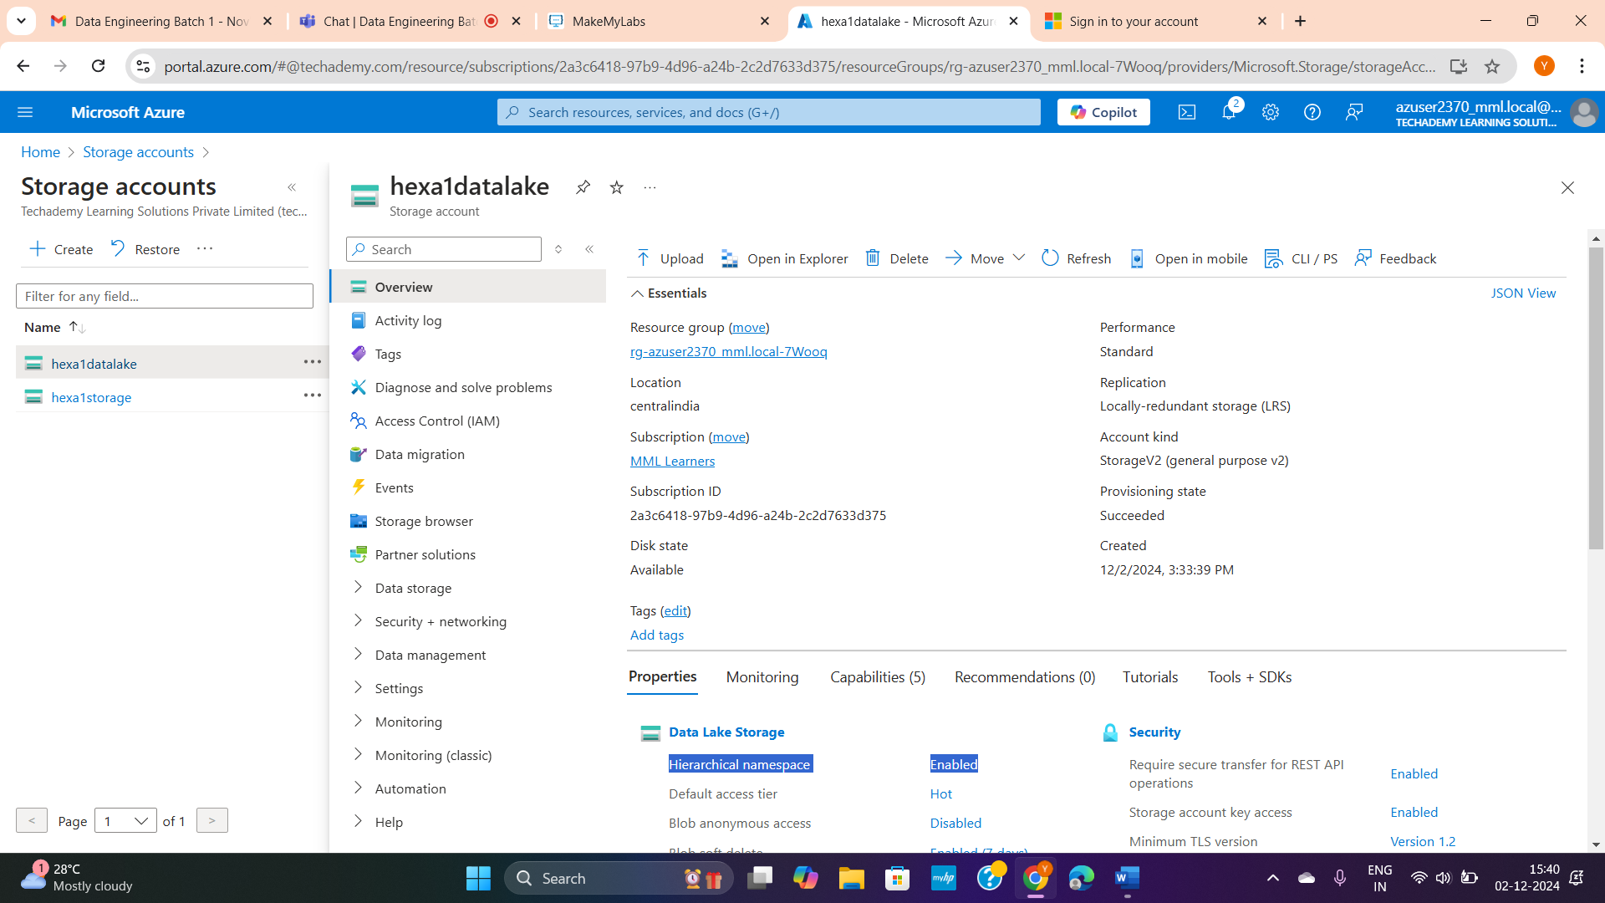

**Create container(folder) inside blob data storage**

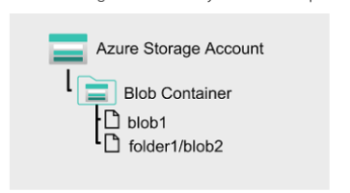

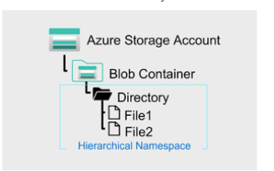

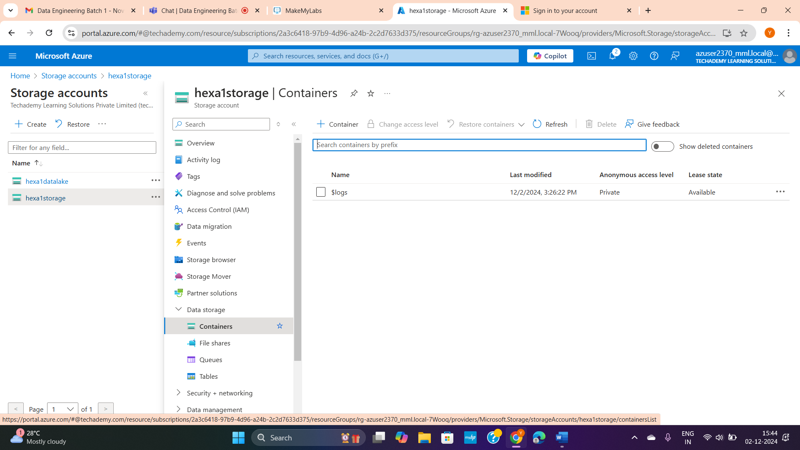

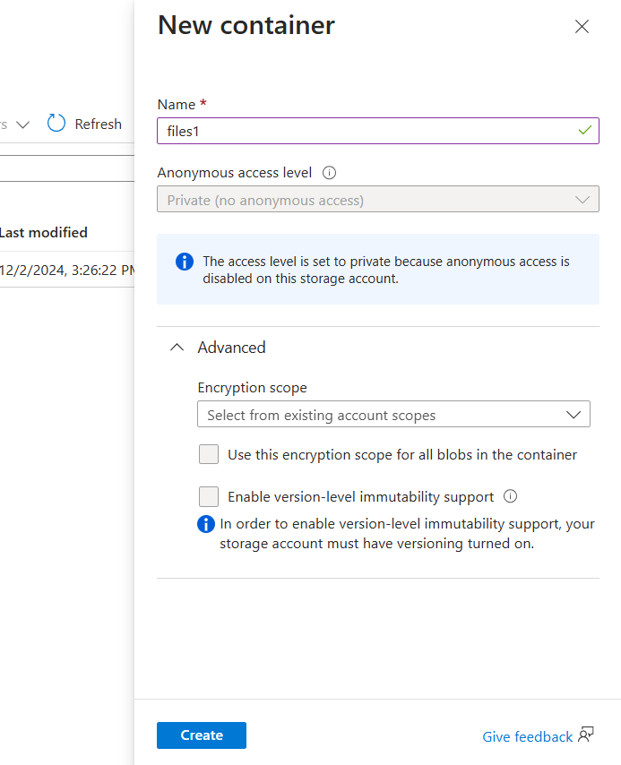

Inside container upload required file:

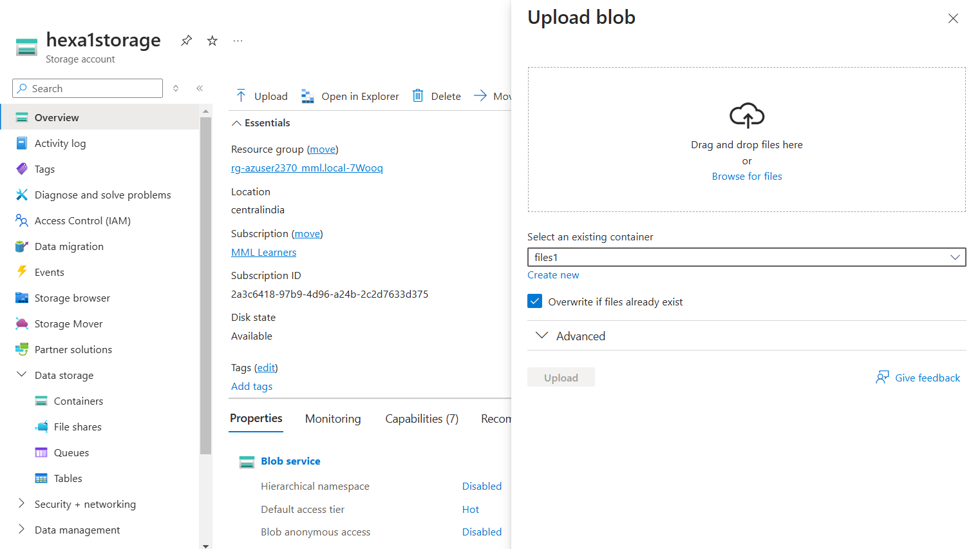

(Available access tier)